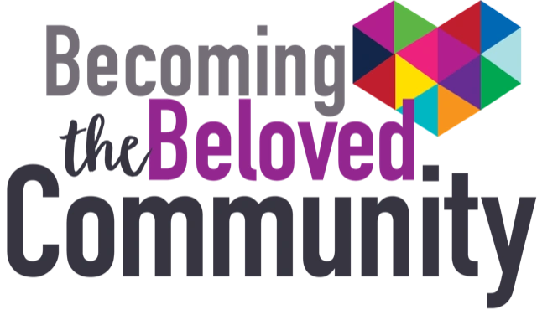

Intentionally Collaborating to Become the Beloved Community

Social Identifiers

- Citizenship
- Educational Level Achieved
- Economic Status
- Second Language
- First Language
- Gender Identity
- Sexual Orientation
- Racial Identity
- Ethnicity
- National Origin
- Culture
- Religion

1. Please describe yourself based on the aforementioned twelve US societal identifiers. _________________________________________________________________________________________________________________________________________________________________________________________________________________________________________________________________________________________________________________

2. Why did you attend this dialogue, “Intentional Listening: How to Love Your Neighbor in the Midst of Terror?” _________________________________________________________________________________________________________________________________________________________________________________________________________________________________________________________________________________________________________________

3. What towns, counties and or faiths did your new family members represent when you participated in the Becoming the Beloved Community multicultural meal and dialogue?

_________________________________________________________________________________________________________________________________________________________________________________________________________________________________________________________________________________________________________________

4. Do you think participating in programs like this is an effective way to address society’s ethnic, racial and cultural problems? Please explain why or why not?
_________________________________________________________________________________________________________________________________________________________________________________________________________________________________________________________________________________________________________________

5. What activities did your new Becoming the Beloved Community family agree that you would participate in before April 4, 2020, the 52nd anniversary date of Rev. Dr. Martin Luther King Jr’s assassination?

_______________________________________________________________________________________________________________________________________________________________________________________________________________________________________________________________________________________________________________________________________________________________________

6. Would you be interested in continuing to participate in more programs like this? Why or why not?
________________________________________________________________________________________________________________________________________________________________________________________________________________________________________________________________________________________________________________

7. What other suggestions do you have for addressing society’s ethnic, racial, and cultural programs?
_________________________________________________________________________________________________________________________________________________________________________________________________________________________________________________________________________________________________________________

